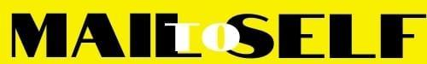

Dear aunt Sandra,
Thank you for the gift you sent me on my birthday. It made my day! I am blessed to have a kind, loving, and caring aunt like you. It was so thoughtful of you to send me the generous gift knowing well that I am saving for my college. I cherish and admire your kindness and how you take care of not only me, but all your nieces and nephews.
Thank you for being a role model for me and showing me how much it means to always put others before yourself. I will make you proud one day and never let your encouragement go to waste.
Many thanks for everything that you do for me.
Lovingly yours
Sam (your name)

